

**ME 399**

**Project: Submerged Remote-Control Vehicle (SRCV)**

*Submitted by*

**Sanket Dayal**

**Shreyash Agrawal**

*Under the supervision of*

**Prof. Pratik Mutha**

**Maker Bhavan**

**IIT Gandhinagar**

**Acknowledgment**

I extend my heartfelt gratitude to Prof. Pratik Mutha for his invaluable guidance, mentorship, and unwavering support throughout the duration of this project. Prof. Mutha's expertise, encouragement, and commitment to excellence have been instrumental in shaping the success of the Submerged Remote-Control Vehicle (SRCV) project.

I would like to express my sincere thanks to Anirudh Mali sir, Pupul sir, Pankaj sir for their collaboration, insights, and technical assistance. Their contributions have enriched the project and added significant value to its outcomes.

I am grateful to the IIT GANDHINAGAR for providing the necessary resources and facilities that enabled the successful execution of the SRCV project.

Lastly, I would like to express my appreciation to all those who, directly or indirectly, contributed to the successful completion of this project. Your support has been indispensable.

Sanket Dayal

Shreyash Agrawal

**ABSTRACT:**

The Submerged Remote-Control Vehicle (SRCV) presented in this project is an innovative underwater vehicle designed for versatile applications in aquatic environments. The SRCV features a cylindrical acrylic hull housing six Brushless DC (BLDC) motors strategically placed as thrusters for enhanced manoeuvrability and control.

The propulsion system is driven by six BLDC motors, each serving as an independent thruster, providing precise control over the SRCV's movement in various directions. The motors are controlled through a custom-designed Printed Circuit Board (PCB). The PCB includes power supply lines and signal wires, optimizing the efficiency of the SRCV's propulsion system.

Power is supplied to the SRCV through a 12V, 50A Switched-Mode Power Supply (SMPS), ensuring a reliable and consistent power source for optimal performance.

**TABLE OF CONTENT:**

1. INTRODUCTION……………………………………………………………………………………5

Historical Context………………………………………………………………..5

Significance and Applications……………………………………………… 6

Thruster configuration…………………………………………………………6

Vector analysis…………………………………………………………………….7

2.Power supply and distribution……………………………………………….8

Power flow………………………………………………………………………….8

Signal flow………………………………………………………………………….9

PCB Design………………………………………………………………………….10

3. Design of SRCV………………………………………………………………………12

Thruster arrangement…………………………………………………………12

Degree of freedom……………………………………………………………..12

Components……………………………………………………………………….14

4. Actual design……………………………………………………………………….17

5. Calculations………………………………………………………………………….20

6. Testing………………………………………………………………………………….22

7. Conclusion……………………………………………………………………….....24

8. References............................................................................... 25

**INTRODUCTION:**

Submerged Remote Control Vehicles (SRCVs) represent a category of underwater robotic systems designed for a variety of tasks in aquatic environments. These vehicles are equipped with propulsion systems and control mechanisms, enabling them to navigate underwater spaces with precision. SRCVs play a crucial role in scientific research, exploration, environmental monitoring, and industrial applications, where human access might be challenging or unsafe.

Remotely operated underwater vehicles (ROV) are controlled by one or more operators from the vessel, and are connected to the vessel by a cable, through which control commands and the power supply are supplied to the vehicle. This type of underwater vehicle allows one to solve a wide range of tasks: bottom mapping, inspection work, rescue operations, extraction of objects from the bottom, work to ensure oil and gas complex objects (drilling support, inspection of gas pipeline routes, inspection of structures for breakdowns, performing operations with valves and valves), scientific applications, support for diving operations, work to maintain fish farms, archaeological surveys, inspection of urban communications, inspection of ships, etc. The tasks to be solved are constantly expanding, and the fleet of underwater robots is growing rapidly. Working with the robots is much cheaper than expensive diving work, despite the fact that the initial investment is quite large, although working with the robots cannot replace the entire range of diving work.

**Historical Context:**

The development of underwater remotely operated vehicles can be traced back to the mid-20th century when early submersibles and remotely operated vehicles **(ROVs)** were used for marine exploration and research. Over the years, technological advancements have led to the evolution of **SRCVs**, incorporating sophisticated materials, propulsion systems, and control mechanisms. These vehicles have become integral tools in oceanography, marine biology, archaeology, and various industries.

**Significance and Applications:**

SRCVs are employed for a wide range of applications, including underwater exploration, data collection, pipeline inspection, search and rescue operations, and environmental monitoring. Their ability to operate in challenging and hazardous underwater environments makes them indispensable for tasks that would otherwise be difficult or dangerous for humans.

**THRUSTER CONFIGURATION:**

In our project we have use the six-thruster configuration. The six-thruster configuration is given below,

THRUSTER3

THRUSTER4

TOP VIEW

Classical thruster arrangement systems also use a vector-based approach, which in general makes the control and stabilization systems as complex as for the proposed scheme.

**VECTOR BASE APPROCH:**

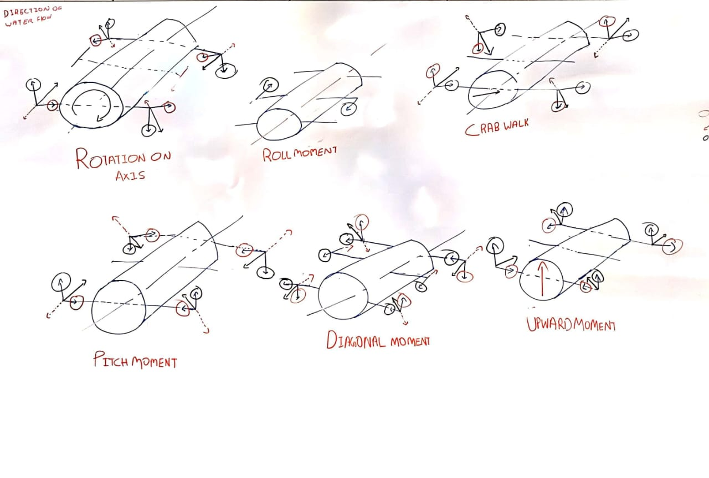

**POWER SUPPLY AND DISTRIBUTION:**

* Power Source:

SMPS: 12V, 50A power supply. This serves as the main power source for the entire system.

* Control System:

Arduino Uno: Microcontroller handling the control logic.

Power: Supplied by one of the ESCs.

Signal Wires: Connected to joystick for control.

* Motor Control:

Bidirectional UBEC ESCs: Electronic Speed Controllers for BLDC motors.

Power: Connected to SMPS for 12V power.

Signal Wires: Connected to Arduino Uno for control.

* Propulsion:

BLDC Motors: Six motors serving as thrusters.

Power: Connected to UBEC ESCs for motor control.

Control: Governed by signals from Arduino Uno through ESCs.

* Control Interface:

Joystick: Input device for controlling the system.

Tether Wire: Connected to Arduino Uno for transmitting control signals.

**Power Flow:**

* Power Supply:

SMPS provides a stable 12V, 50A power source.

* Control System Power:

Arduino Uno is powered by one of the ESCs.

* Motor Power:

UBEC ESCs receive power from the SMPS and provide power to the BLDC motors.

* Control Signal Flow:

Joystick inputs are transmitted through a tether wire to Arduino Uno.

Arduino Uno processes the inputs and sends control signals to UBEC ESCs.

UBEC ESCs interpret signals and adjust the power supplied to BLDC motors accordingly.

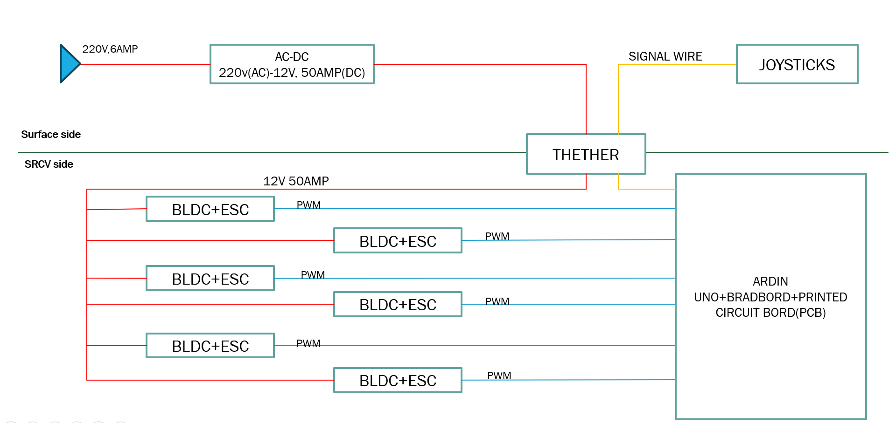

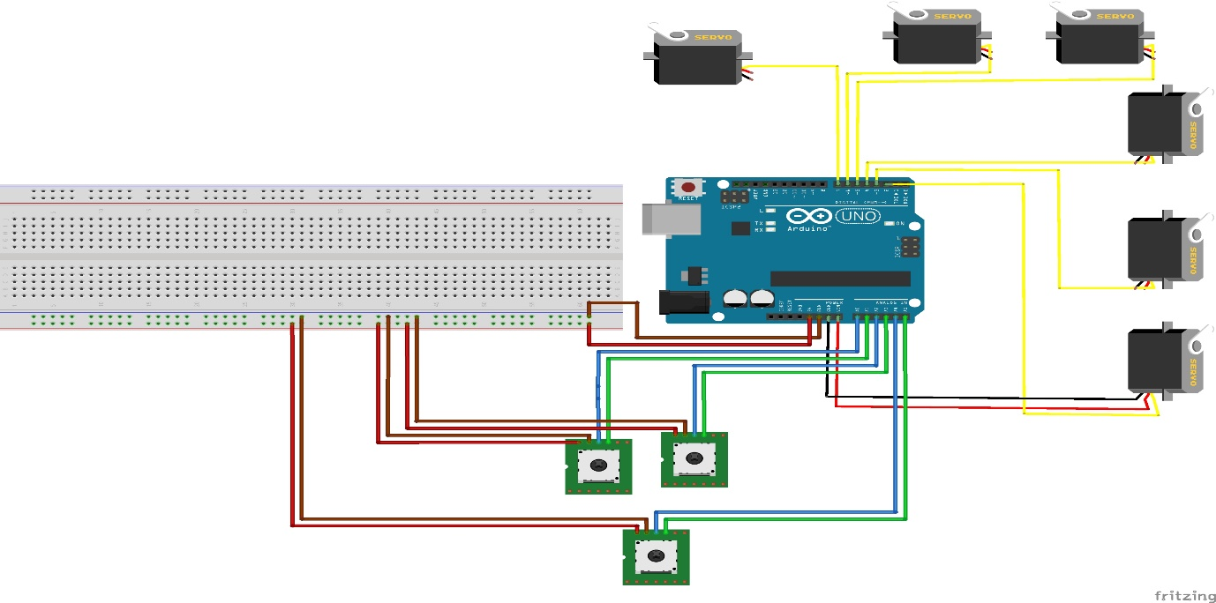

**PCB DESIGN:**

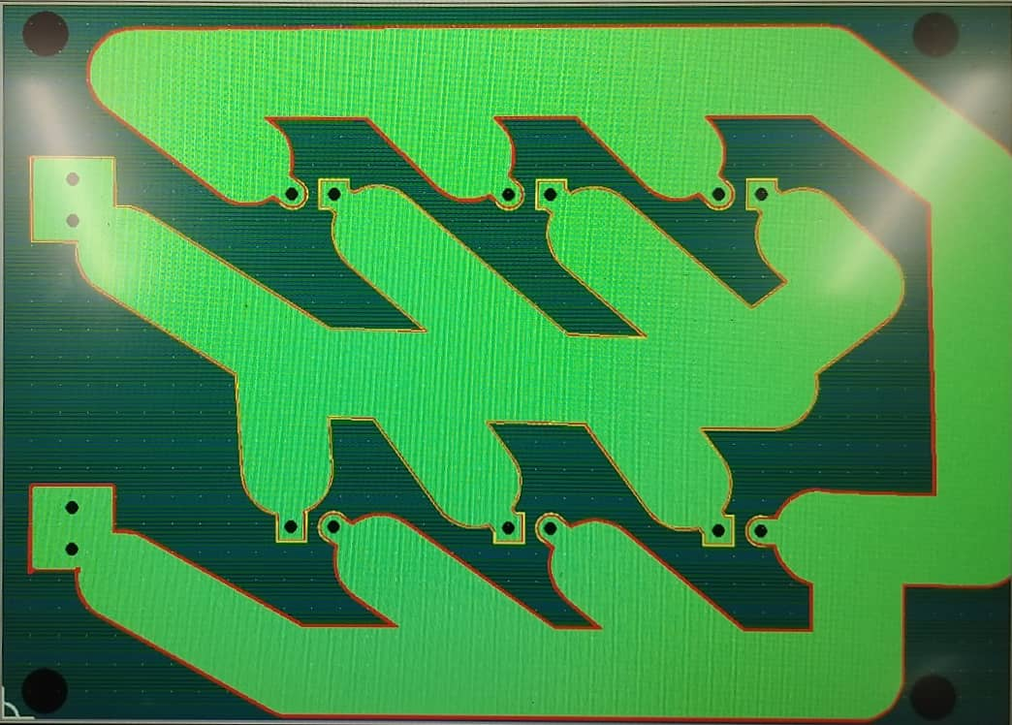

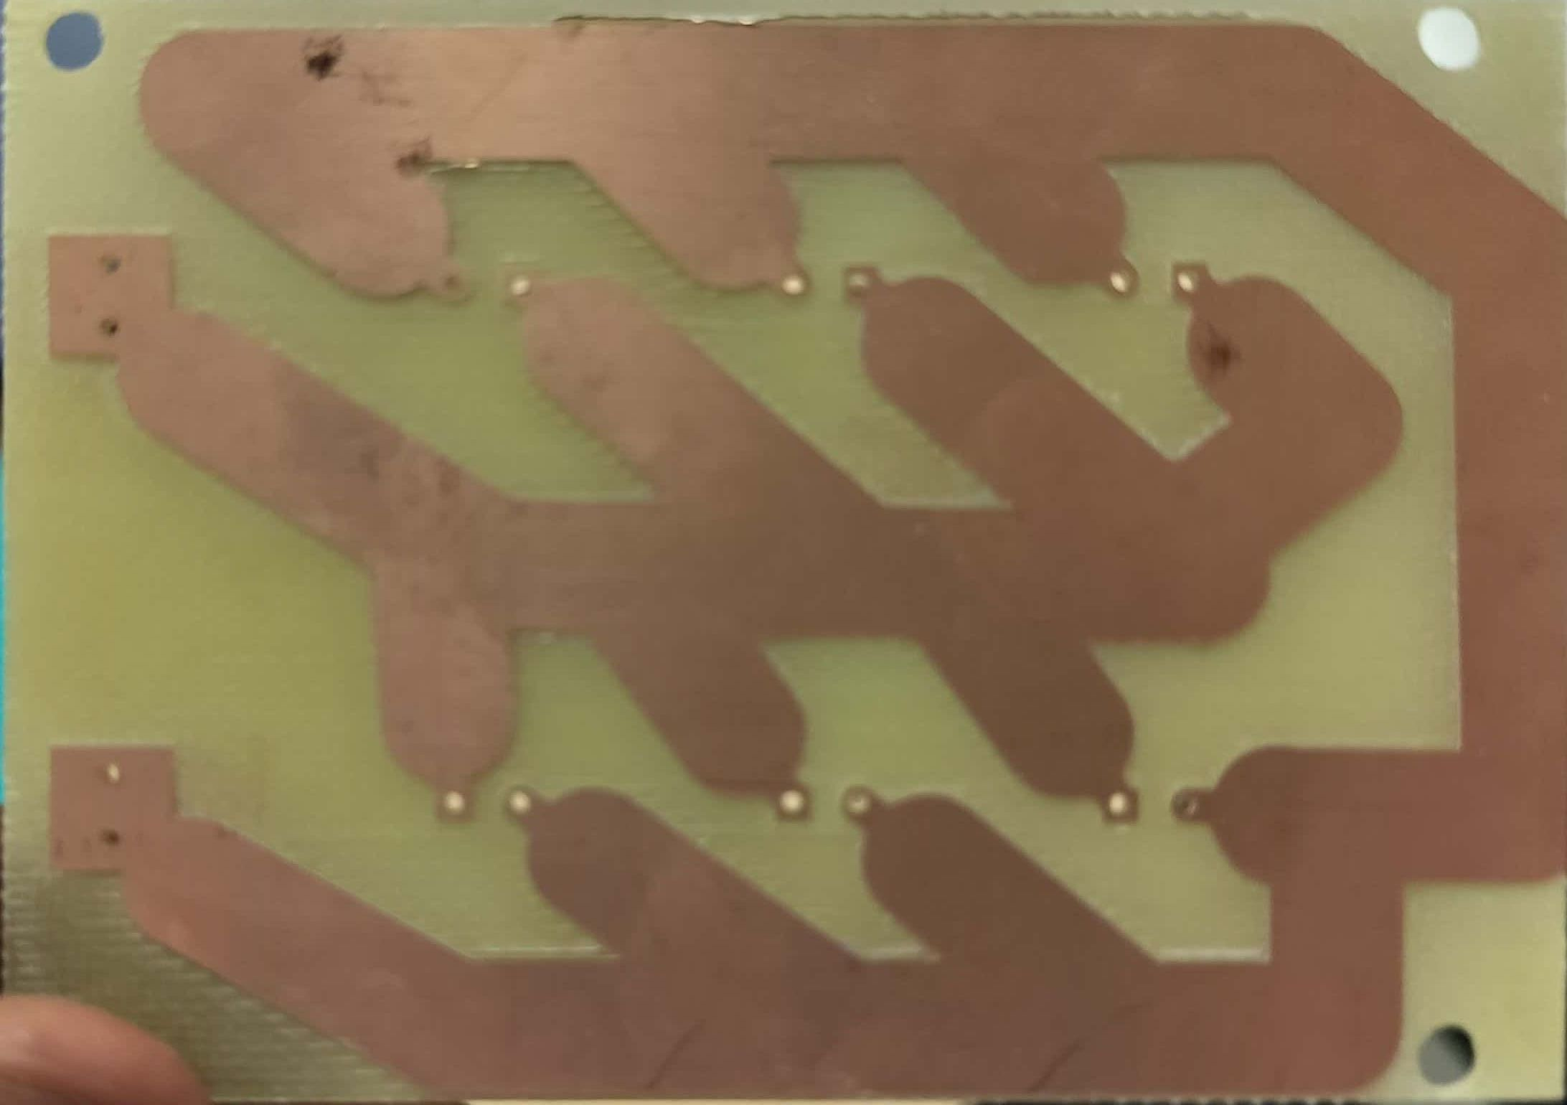

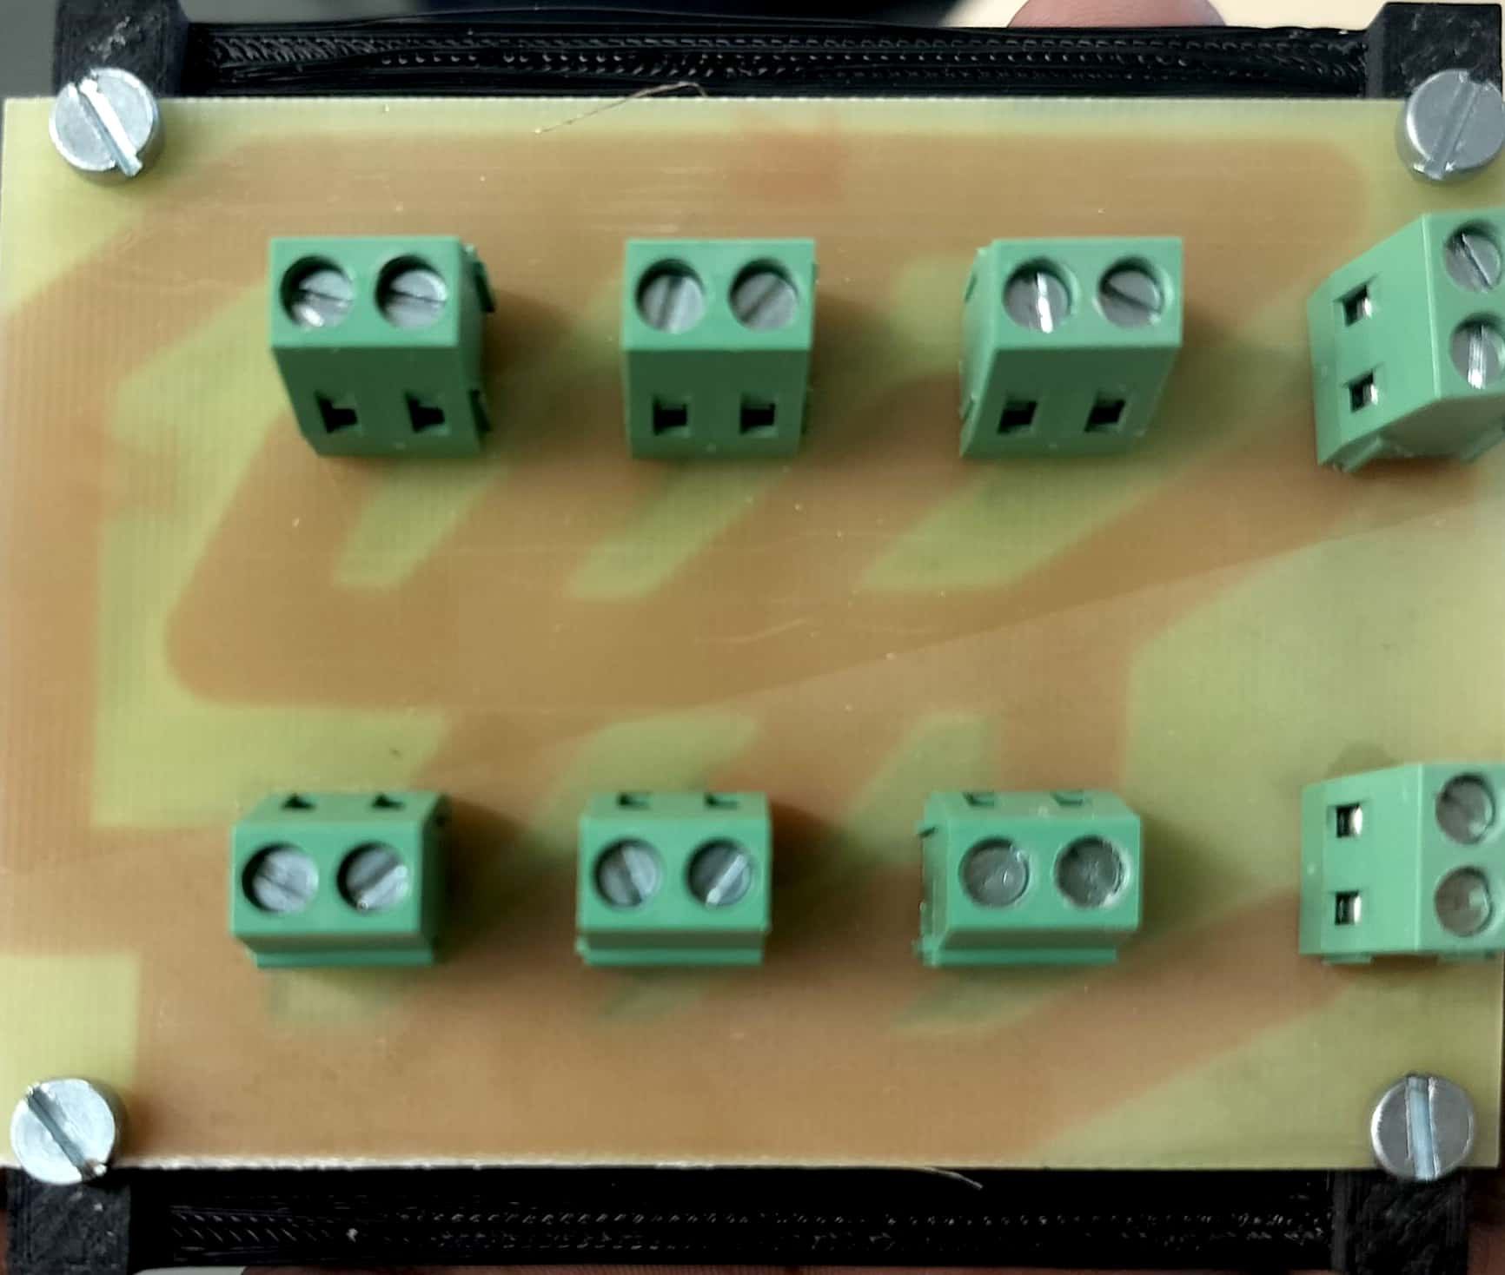

**DESIGN AND COMPONENTS:**

The design of the Submerged Remote-Control Vehicle (SRCV) is structured around achieving six degrees of freedom, enhancing its manoeuvrability and control in underwater environments. This innovative design incorporates a total of six thrusters, strategically arranged to provide control over roll, pitch, and yaw moments.

**1. Thruster Arrangement:**

a. Roll and Pitch Control (Four Thrusters):

* Orientation: Four thrusters are arranged in pairs, positioned vertically.
* Inclination: Each thruster is inclined at a 45-degree angle to the vertical axis.
* Functionality: The paired thrusters work in tandem to generate roll and pitch moments.
* Roll Control: Differential thrust adjustments between the pairs create a rolling motion.
* Pitch Control: Simultaneous adjustments control the pitch orientation of the SRCV.

b. Yaw Control (Two Thrusters):

* Orientation: Two thrusters are positioned horizontally.
* Functionality: The horizontally positioned thrusters are dedicated to generating yaw moments.
* Yaw Control: Differential thrust adjustments between the horizontal thrusters facilitate precise yaw control.

**2. Degrees of Freedom:**

The SRCV achieves six degrees of freedom through the following motions:

* Roll (Rotation around the longitudinal axis):

Controlled by varying thrust between the vertically inclined thruster pairs.

* Pitch (Rotation around the transverse axis):

Controlled by coordinated adjustments in thrust from the inclined thruster pairs.

* Yaw (Rotation around the vertical axis):

Controlled by modulating the thrust output from the horizontally positioned thrusters.

* Surge (Linear forward/backward motion):

Thrust differentials between the front and rear thruster pairs contribute to forward or backward movement.

* Sway (Linear left/right motion):

Thrust differentials between the left and right thruster pairs contribute to lateral motion.

* Heave (Linear up/down motion):

Vertical adjustments in thrust from all thrusters collectively control the depth of the SRCV.

The 3d model of the SRCV is given below,

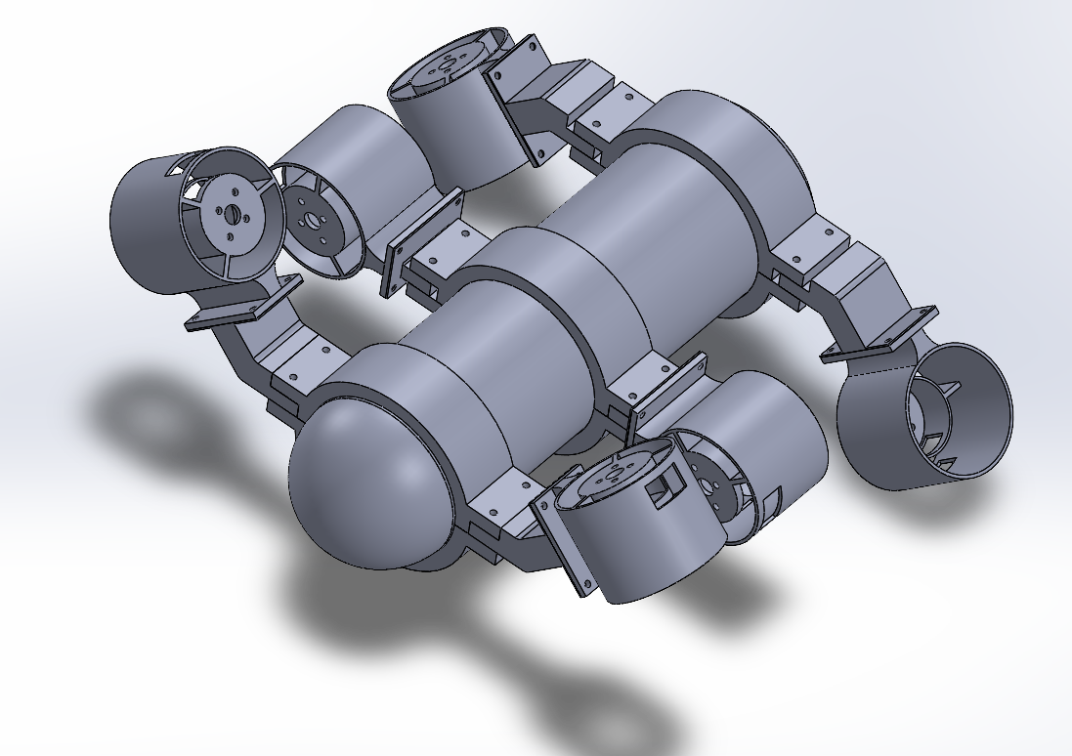

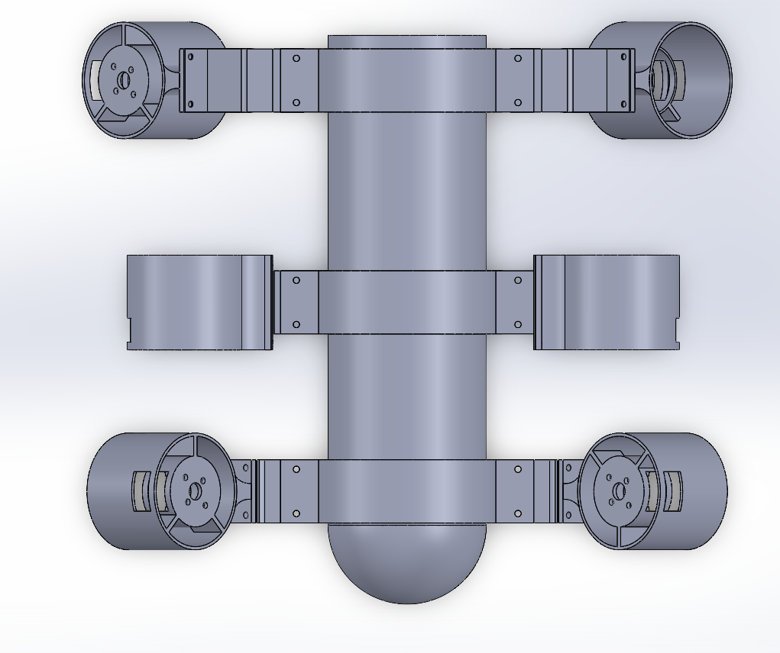

**COMPONENTS:**

The following components are use in the SRCCV,

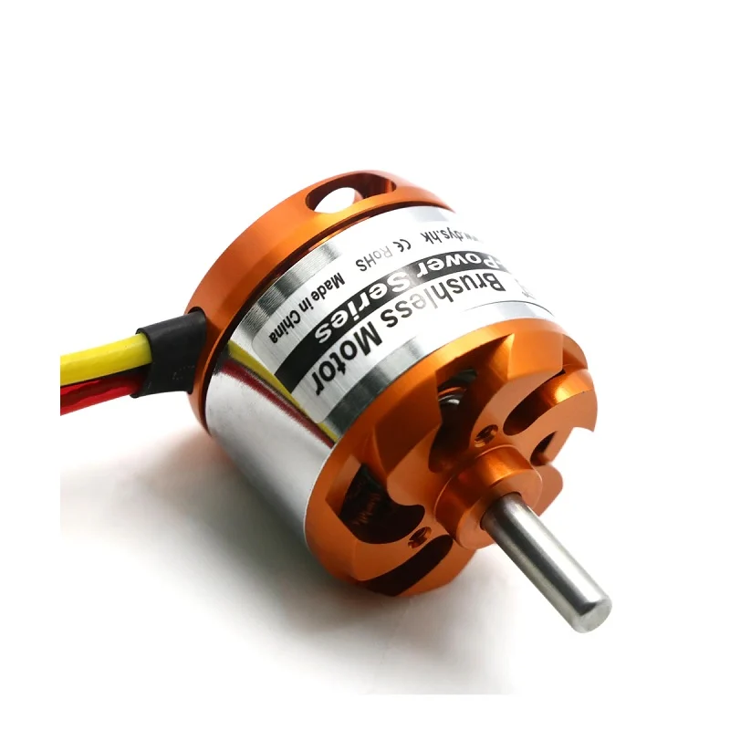 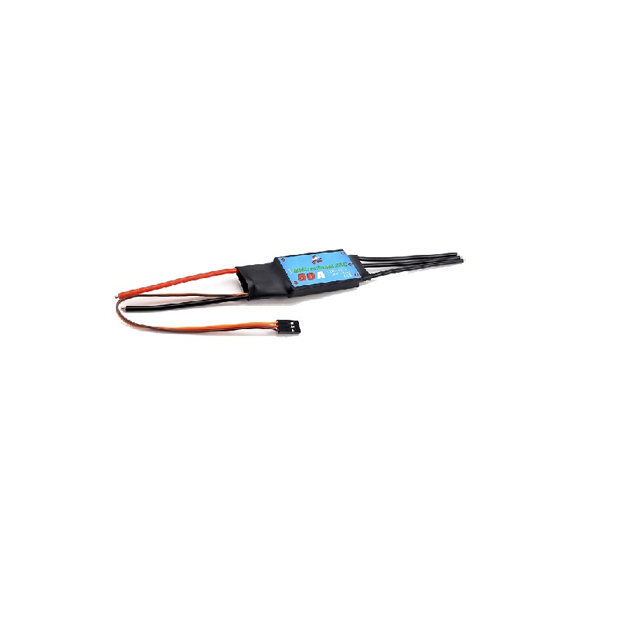 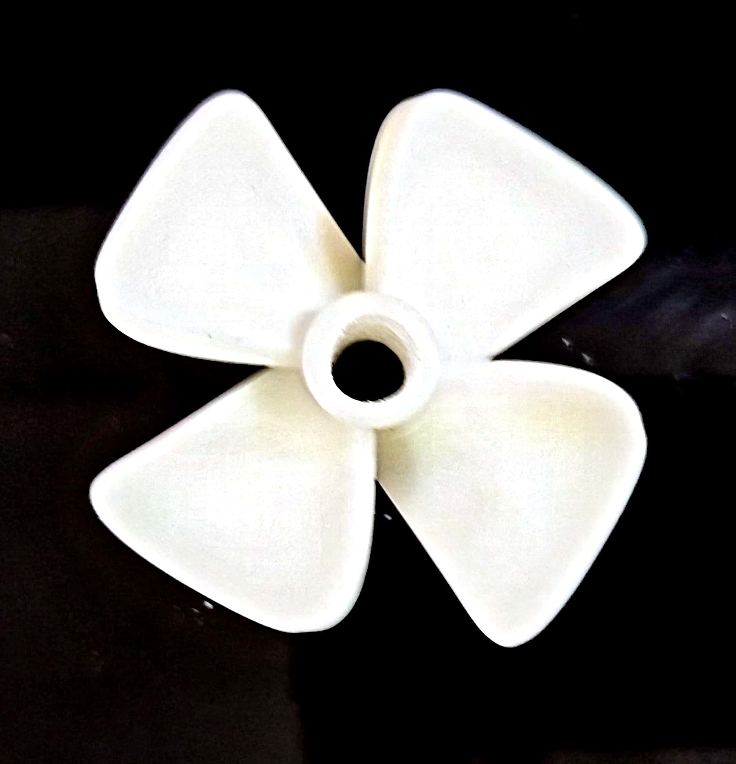

BLDC MOTOR BIDIRECTIONLA ESC PROPELLER

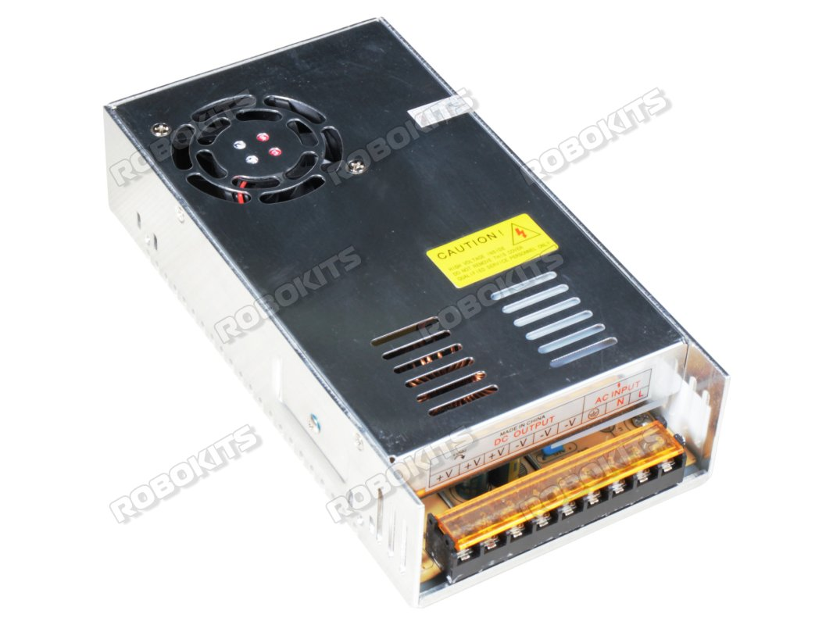 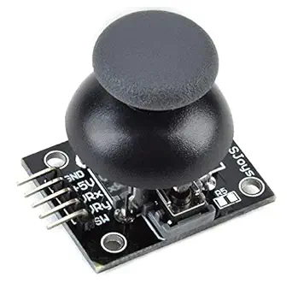 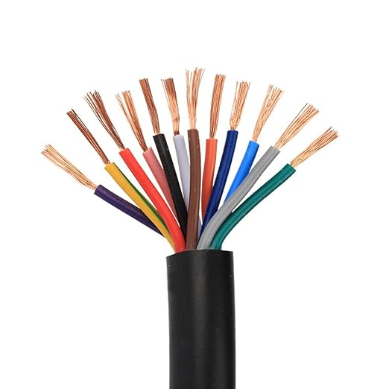

SMPS JOYSTICK SIGNAL WIRE

 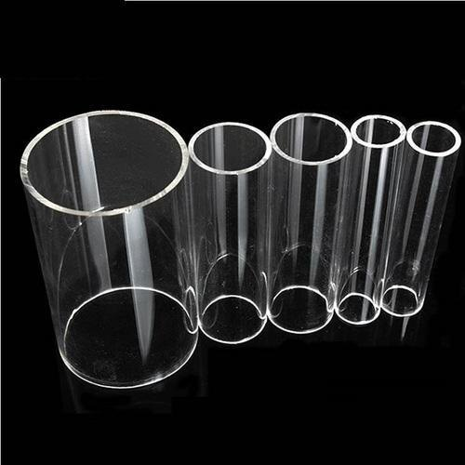

PRINTED CIRCUIT BORD ACRYLIC CYLINDER

**ACTUAL DESIGN AND PARTS**

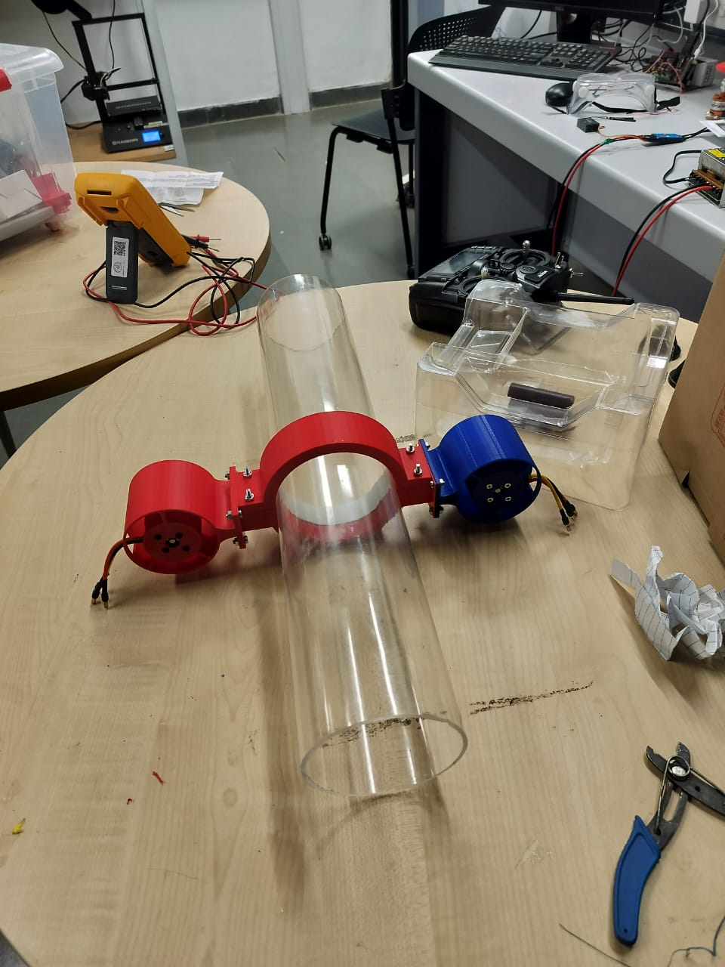 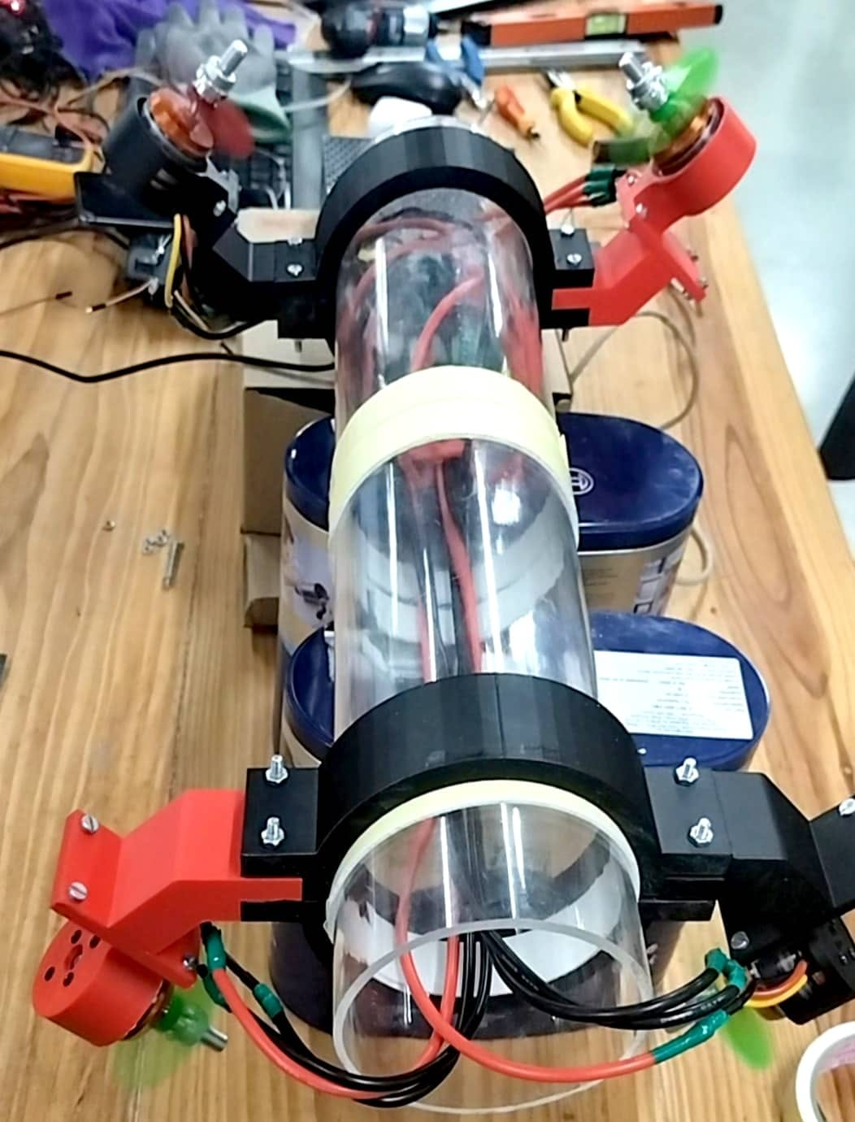

* Initially we have printed all the parts and the assemble all of them together. After that we have designed the PCB and insert it into the cylinder connecting all the ESC to the PCB.

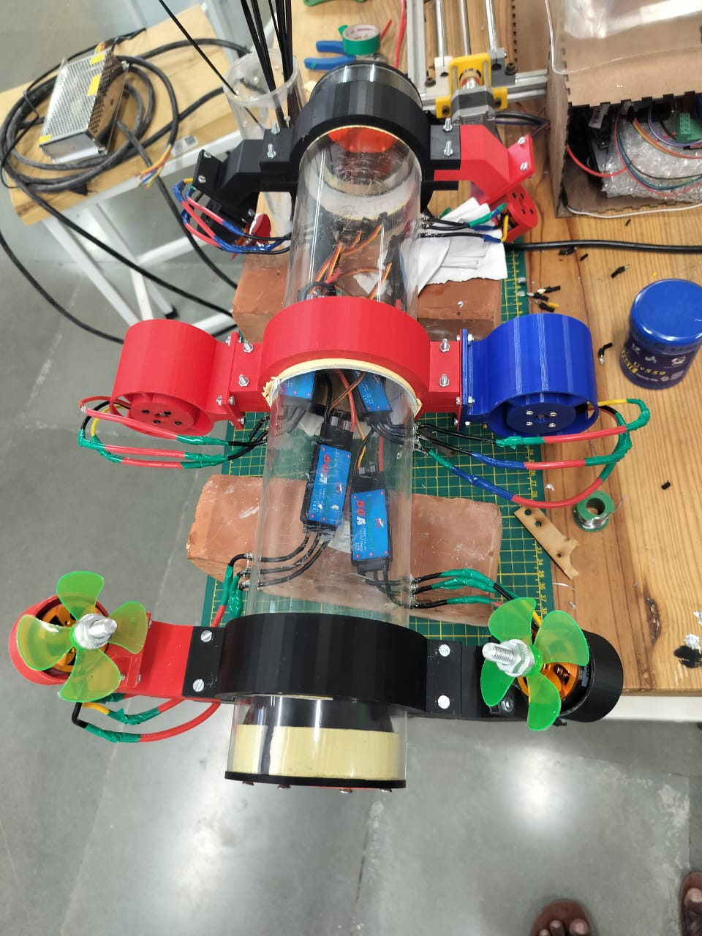 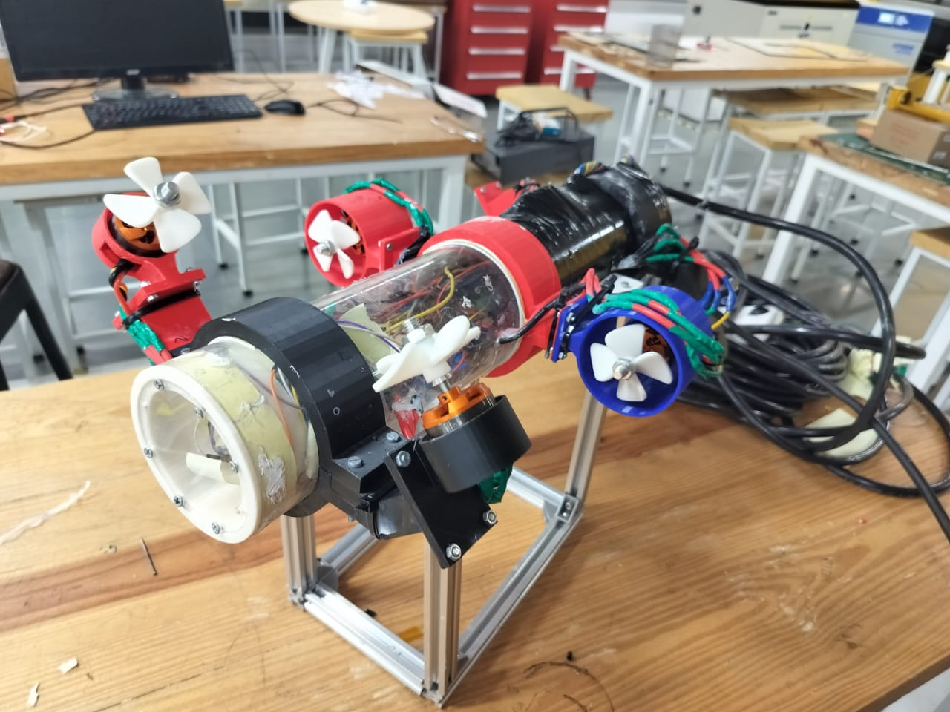

* We have drilled the hole in the acrylic and connect the wire to the BLDC motor.
* After that we have connect the connection of the Arduino uno to the ESC and the joysticks for the signal communication.
* After putting all the things in the acrylic cylinder, we have made the acrylic cylinder air tight and water proof by applying the resign on the acrylic

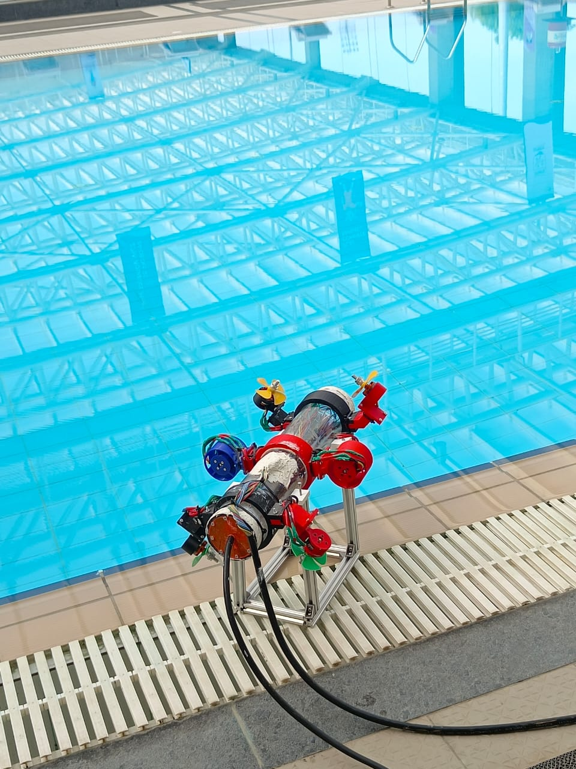

* Finally, after all the testing the SRCV is ready to dive inside the water. So that we can check the performance of the SRCV.
* The different 3D parts of the SRCV are given below,

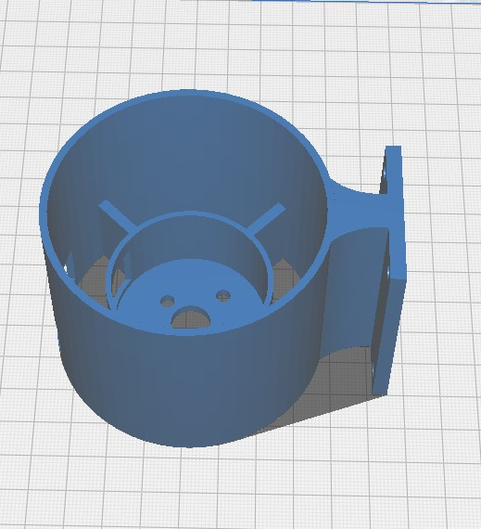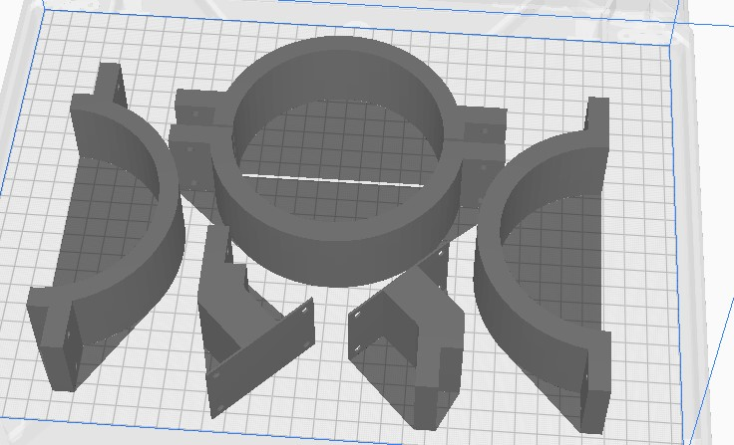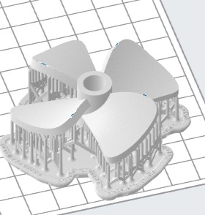

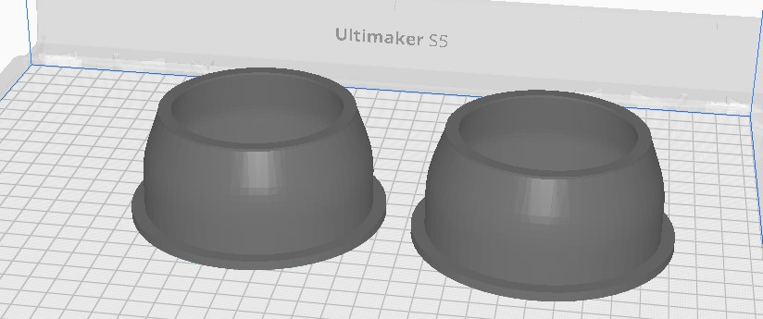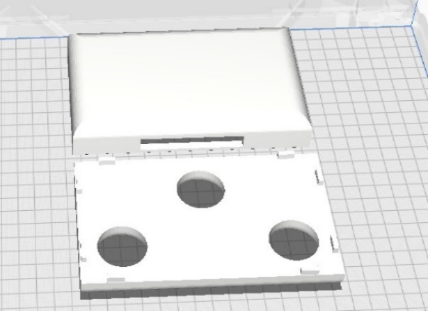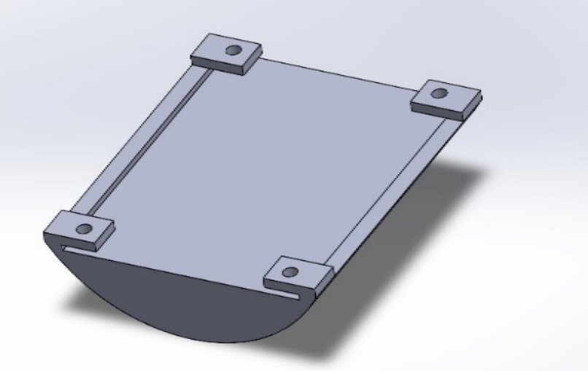

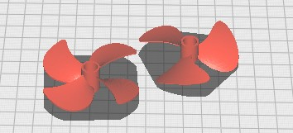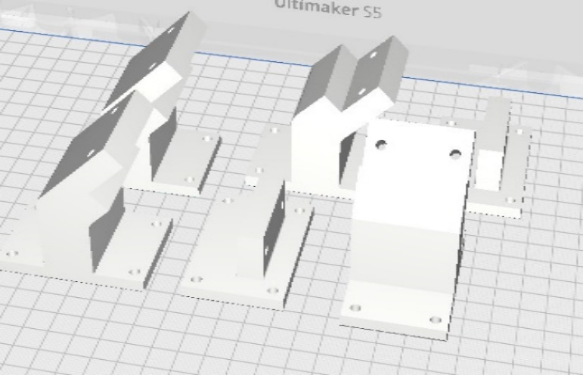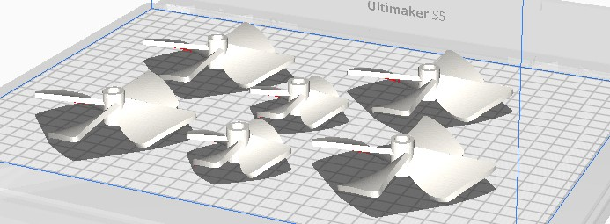

**THRUST REQUIRED:**

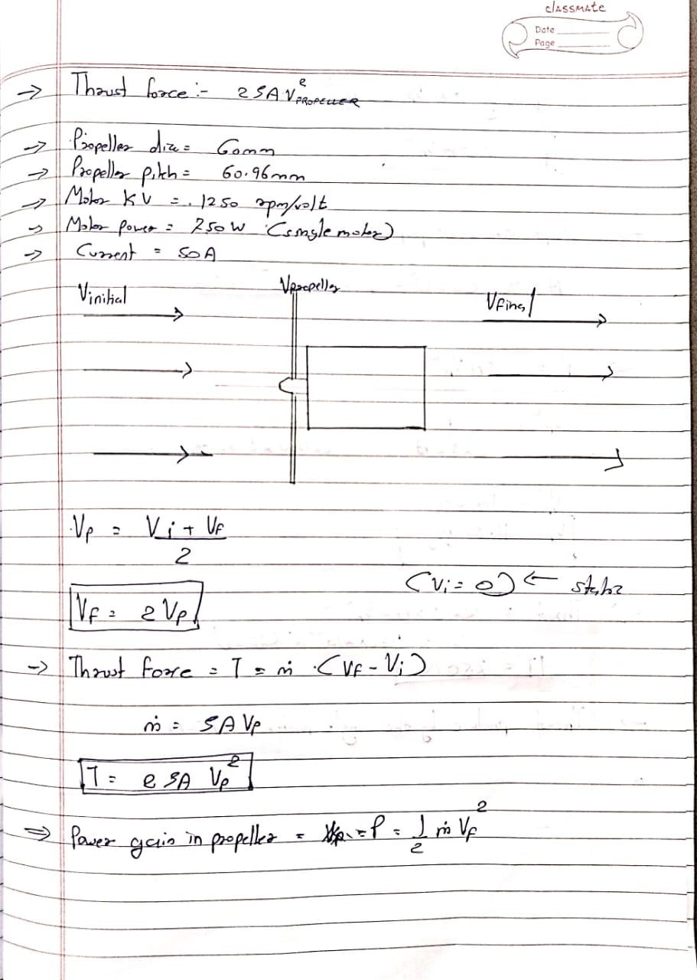

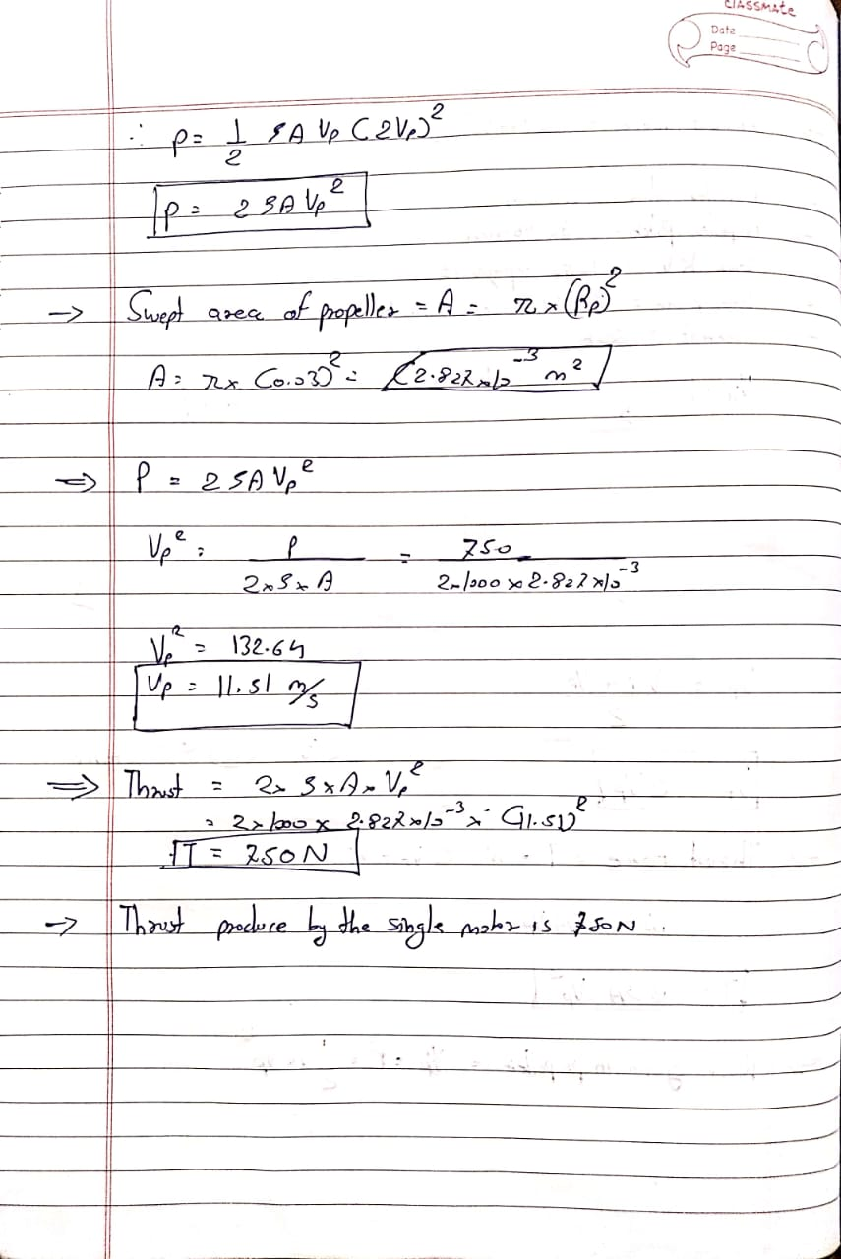

Thus, the thrust produce by the vehicle is 4500N.

**TESTING:**

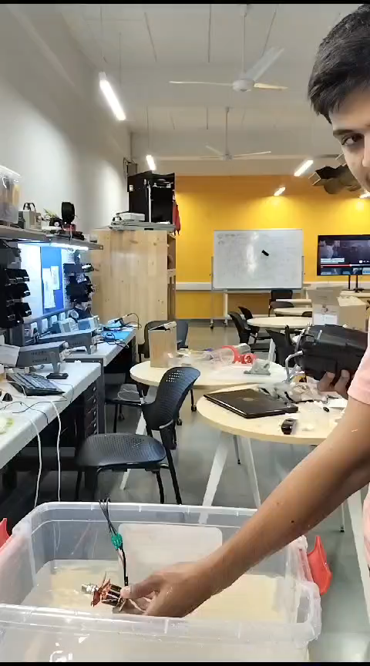Test-1:

* Initially we have tested the BLDC
* motor under water to conform that it is working inside the water or not.
* And the test is successful, BLDC is working inside the water.

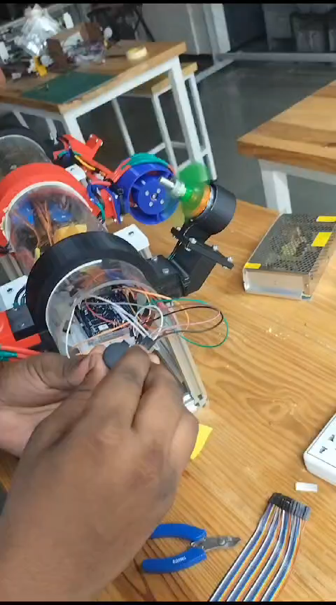Test-2:

* Connecting the BLDC with the joystick and tested the individual motor by individual joystick, to ensure the connection and the signal commination.

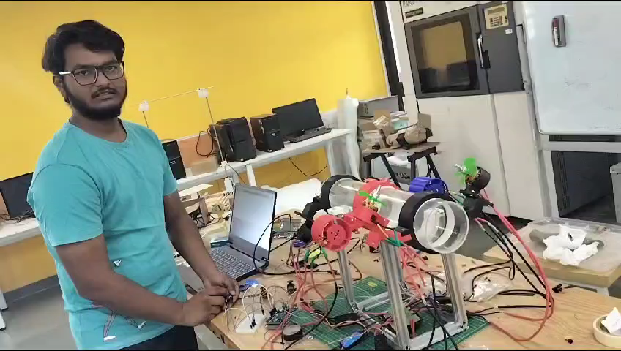 Test-3:

* After ensuring all the connections we have connecter all the BLDC with the joysticks, to ensure that all the motor are working at the same time or not.
* Error: if we immediately change the direction of the motor then the system is restarted automatically

Test-4:

* 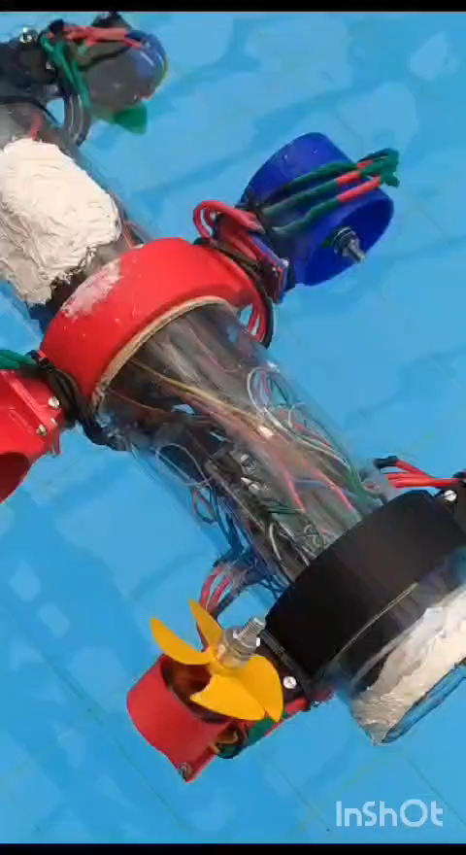finally, after all the test we have tested it in the water. In that we face three problems,
* vehicle is not heavier that water buoyancy therefore it is not sinking
* propellers are not stuffiest hard.
* Power supply is not sufficient.

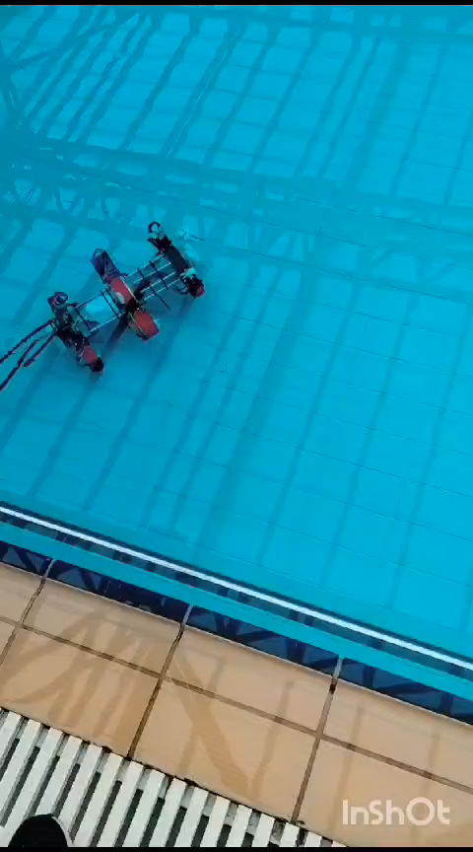Test-5:

* After solving all the previous problem, we have tested again in the water.
* This time the vehicle is working properly inside the water.
* We are facing only one problem that is given in the problem three error.
* We have gone through all the possible solutions but we can’t figure it out where the actual problem is

Because of that the vehicle is moving to some distance and because of restarting of the system the vehicle remain ideal to that position.

**CONCLUSION:**

* The primary objective of our project was to conceptualize and construct a cutting-edge SRCV within the confines of Maker Bhavan. Our journey towards this goal involved an intricate process, spanning a comprehensive literature survey, meticulous material analysis, intricate SolidWorks modelling, and a judicious cost analysis.
* The construction of the ROV body materialized through a fusion of acrylic sheets and precision engineered 3D printed parts, attesting to the meticulousness of our material selection process. The deployment of brushless motors, synchronized with a six-channel transmitter, provided us with precise control over the SRCV intricate movements.
* After testing we reached out the conclusion that instead of using BLDC, we should have to use the actual thruster which made waterproof and are designed to for the underwater with accurate propeller design and required thrust.
* Another point is to cover the acrylic cylinder with the outer cover which have aerodynamic shape so the darg force is reduce.

* The outer cover should also have different attachments carrying design so that we can place different attachments like robotic arm, etc. in the vehicle
* It also should have additional weight carrying attachments because different water has different densities so sometimes we have to add more weigh or sometimes we have to remove some weigh to make the vehicle stable under water.

REFERENCE:

<https://iopscience.iop.org/article/10.1088/1742-6596/962/1/012017>

<https://www.researchgate.net/publication/371315363_Design_and_Implementation_of_a_Six-Degrees-of-Freedom_Underwater_Remotely_Operated_Vehicle?enrichId=rgreq-1b600606f600b80593c76ca022d39152-XXX&enrichSource=Y292ZXJQYWdlOzM3MTMxNTM2MztBUzoxMTQzMTI4MTE2NTUxOTIzN0AxNjg2MDQ1MDk4OTQw&el=1_x_3&_esc=publicationCoverPdf>

Design and Modelling of an Experimental ROV with Six Degrees of Freedom

Aleksey Kabanov , Vadim Kramar and Igor Ermakov

hhttps://www.researchgate.net/publication/371315363_Design_and_Implementation_of_a_Six-Degrees-of-Freedom_Underwater_Remotely_Operated_Vehicle?enrichId=rgreq-1b600606f600b80593c76ca022d39152-XXX&enrichSource=Y292ZXJQYWdlOzM3MTMxNTM2MztBUzoxMTQzMTI4MTE2NTUxOTIzN0AxNjg2MDQ1MDk4OTQw&el=1_x_3&_esc=publicationCoverPdfttps://www.researchgate.net/publication/371315363_Design_and_Implementation_of_a_Six-Degrees-of-Freedom_Underwater_Remotely_Operated_Vehicle?enrichId=rgreq-1b600606f600b80593c76ca022d39152-XXX&enrichSource=Y292ZXJQYWdlOzM3MTMxNTM2MztBUzoxMTQzMTI4MTE2NTUxOTIzN0AxNjg2MDQ1MDk4OTQw&el=1_x_3&_esc=publicationCoverPdfDesign and Implementation of a Six-Degrees-of-Freedom Underwater Remotely Operated Vehicle

Design and Implementation of a Six-Degrees-of-Freedom Underwater Remotely Operated Vehicle

Design and Implementation of a Six-Degrees-of-Freedom Underwater Remotely Operated Vehicle

Design and Implementation of a Six-Degrees-of-Freedom Underwater Remotely Operated Veh